Server Monitoring Configuration Guide

1. Setting Domain details to Monitor : Launch the Application
- Navigate to the following directory: C:\SQLMaintenancePlanner\OSMonitor.
- Locate DomainServerMonitoringSQLiteWinRM_W.exe.
- Right-click the executable and select Run as Administrator.
- If a User Account Control (UAC) prompt appears ("Do you want to allow this app to make changes to your device?"), click Yes.

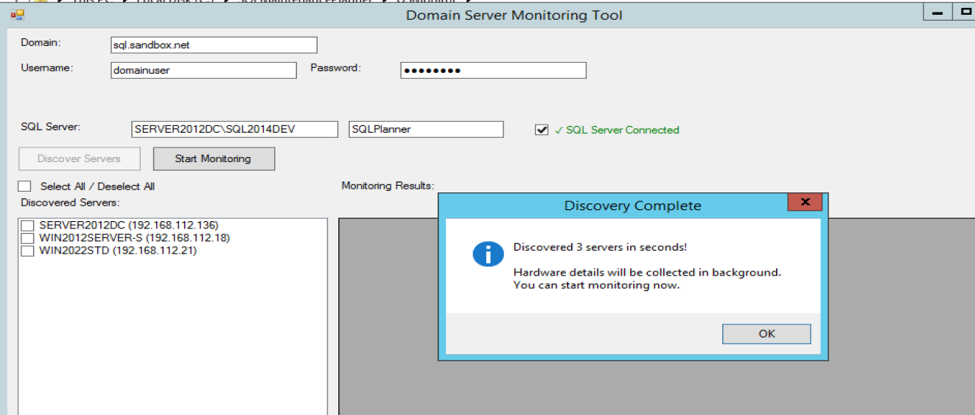
2. Connection & Credentials Setup
Fill in the following fields in the application interface:
- Domain: Enter the fully qualified domain name (FQDN) of the environment you wish to monitor.
- Username / Password: Provide valid Domain User credentials with sufficient permissions to access the target servers.
- SQL Server: Enter the hostname or IP address of the server hosting the SQLPlanner database.
- Database: Ensure this is set to SQLPlanner (default).
3. Database Connectivity & Permissions
- Enable the Connect SQL Server checkbox to initiate a connection test.
- A green tick indicates a successful connection.
- Troubleshooting Connection Failures:
  - If the connection fails, ensure the current logged-in Windows user is assigned the sysadmin role on the target SQL Server.
  - Required Service Account: You must manually add the "SYSTEM" user to the SQL Server logins. This is mandatory as the monitoring jobs execute under the System account.
4. Server Discovery
Once the connection is verified, click the Discover Servers button. The process may take approximately one minute to identify all available servers within the specified domain.

Automating & Scheduling Monitoring
Follow these steps to configure the automated monitoring schedule via the web interface:
- Access the Web Portal:
Open your web browser and navigate to the SQL Planner URL: http://[IPAddress]/SQLPlanner.
- Authentication: Log in using the default administrative credentials:
Username: Admin Password: Admin
- Navigate to Settings:
Once logged in, go to the Settings menu and select the Win Server Monitor Settings tab.
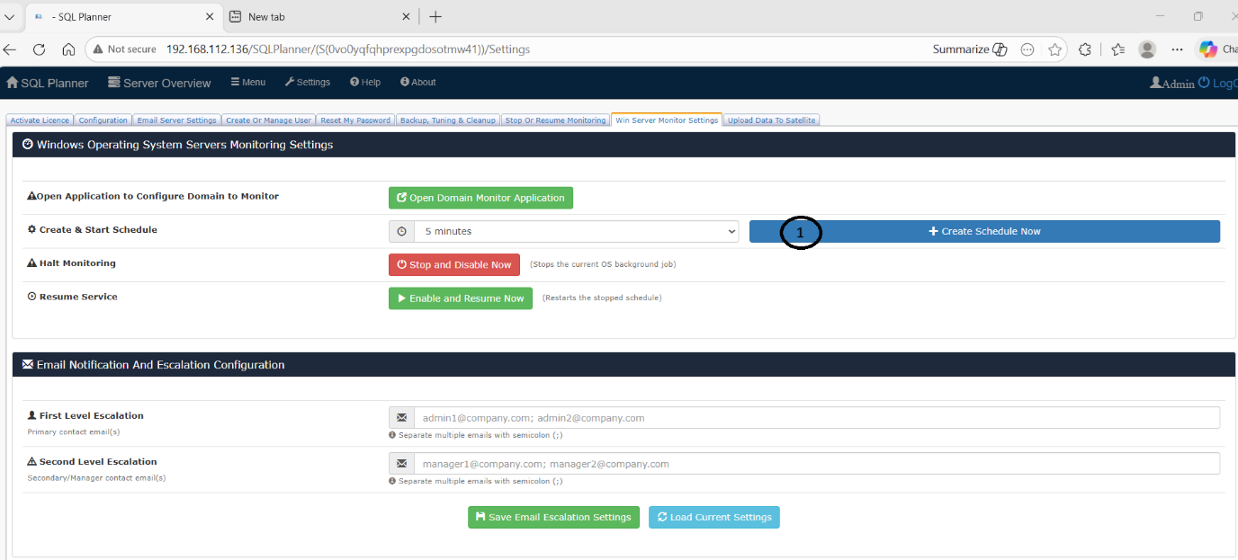
- Initiate Scheduling:
Click the "Create Schedule Now" button to automate the server monitoring process.

Configuring Email Alert Notifications
To ensure critical alerts reach the appropriate team members, follow these configuration steps for Database Mail and the SQL Planner application.

1. Configure SQL Server Database Mail
Before the application can send alerts, you must establish an SMTP profile within SQL Server:
- Navigate to the following directory:
C:\SQLMaintenancePlanner\Scripts\EmailProfileCreationCode\
- Open the script: SQL_Mail_Profile_Creation_T-SQLCode.sql.
- Edit the script by providing your specific details:
  - SMTP Server Address
  - User ID & Password
  - Port Number
- Execute the script in SQL Server Management Studio (SSMS).
- Test the configuration: Follow the instructions within the script to send a test email to verify that the SMTP settings are correct.
2. Set Up Alert Recipients
- Log in to the SQL Planner web application.
- Navigate to Settings > Win Server Monitoring tab.
- Locate the First Level Escalation email text box.
- Enter the email addresses of all recipients who should receive alert notifications (use a semicolon or comma as a separator if required).

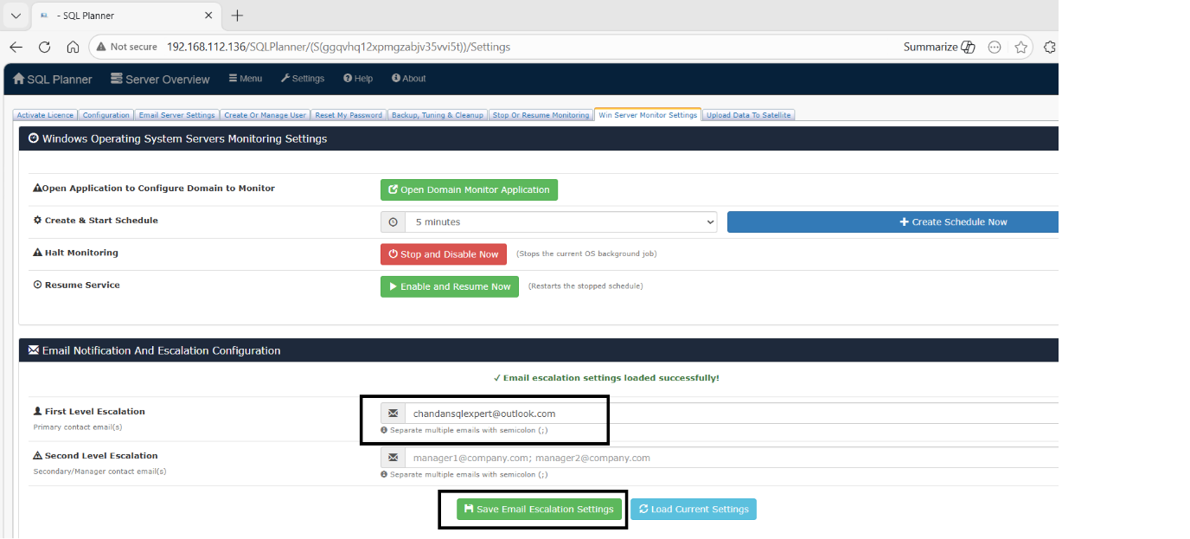

3. Link SQL Planner to the Email Profile
- Switch to the Email Server Setting tab.
- Define the SMTP Database Mail settings the application should use:
  - DB Server Credentials: Provide the credentials for the database server.
  - DB Email Profile Name: Enter the exact name of the profile created in Step 1.
  - Test Email: Provide a recipient address to send a final test email to confirm the integration between SQL Planner and SQL Database Mail is functional.

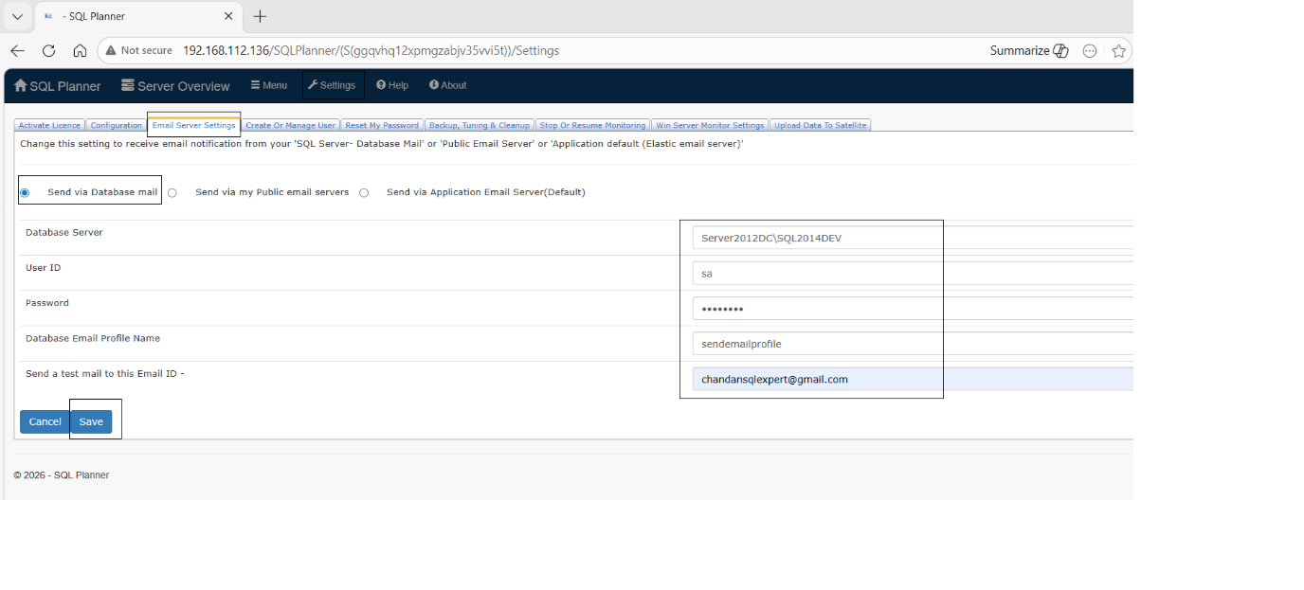

Wait for 5 minutes for complete data collection.

